

**CLEAR Huddersfield Timetable**

**April 2022**

***(starting from Monday 4th April)***

|  |  |  |  |
| --- | --- | --- | --- |
| **EXTRAS** |  |  |  |
| **Wed 6th April**  **Tues 19th April**  **Fri 22nd April**  **Mon 25th April** | Animal Therapy  (Sign up through keyworker)  BAME Group  Yoga  Attic Stories/ Open Mic Night  (Sign up through Worker)  At Lawrence Batley Theatre | 11-12:30pm  3-4:30pm  11-12pm  7:30pm- 9:30pm |  |
|  |  |  |  |
|  |  |  |  |
|  |  |  |  |

|  |  |  |  |  |
| --- | --- | --- | --- | --- |
| **Monday**  **Office closed 18th April – Easter Monday)** | Men’s Group  Hearing Voices Peer Support Group | 2.30pm-4:30pm  5.30pm – 7.00pm |  |  |
| **Tuesday** | Tranquil Tuesdays  Time Travel Tuesdays | 1pm-2:30pm  5:30- 7.30pm |  |  |
| **Wednesday** | Allotment HD2 2QU  Creative Writing | 10am-12pm  5:30pm-7:00pm | Square  Square |  |
| **Thursday** | Words in Mind  Energy Therapy  *(Except 21st April)*  Give…a few Words  (every 2 wks – 7th & 21st) | 2pm-3pm  2pm-3:30pm  3:30-4:30pm | Square  Square    Square |  |
| **Friday**  **(Office closed 15th April -Good Friday)** | All Together  (Sign up through Key Worker) | 1pm – 3pm |  |  |



|  |  |  |  |
| --- | --- | --- | --- |
| **Monday**  **(Office closed on the 2nd May – May Day)** | Men’s Group  Hearing Voices Peer Support Group | 2:30pm-4:30pm  5.30pm– 7.00pm | Square |
| **Tuesday** | Tranquil Tuesdays  Time Travel Tuesdays | 1pm-2:30pm  5:30-7:30pm | Square  Square |
| **Wednesday**  **(No regular groups on 11th May – due to Eid Celebration)** | Allotment (HD2 2QU)  (replaced by Gardening Course 6-20th ) Creative Writing | 10am-12pm    5:30-7:00pm | Square    Square |
| **Thursday** | Words in Mind    Energy Therapy  (except 12th & 26th May)  Give…a few Words  (every 2 wks – 5th & 19th) | 2-3pm  2pm-3:30pm    3:30-4:30pm | Square  Square    Square |
| **Friday** | All Together  (Sign up through Key Worker) | 1-3pm | Square |

**May 2022**

**EXTRAS**



|  |  |  |  |
| --- | --- | --- | --- |
| **Wens 11th May**  **Tues 17th May** | Eid Celebration  (See poster)  BAME Group | 4:00-7:00pm  3:00- 4:30pm |  |
| **Weds 25th May** | Barge Trip  (Sign up through Worker)  At Shepley Marina, Mirfield | 10:30-4:00pm |  |
|  |  |  |  |
|  |  |  |  |

|  |  |  |  |
| --- | --- | --- | --- |
| **Monday** | Men’s Group  Hearing Voices Peer Support Group | 2:30-4:30pm  5.30pm – 7.30pm | Square  Square |
| **Tuesday** | Tranquil Tuesdays  Time Travel Tuesdays | 1pm-2:30pm  5:30-7:30pm | Square  Square |
| **Wednesday** | Allotment HD2 2QU  Creative Writing | 10am-12pm  5:30pm-7:00pm | Square  Square |
| **Thursday**  **(Office closed on the 2nd June – Spring Bank Holiday)** | Words in Mind  Energy Therapy  **(except 2nd June)**  Give…a few Words  (every 2 wks – 2nd,16th & 30th) | 2pm-3pm  2pm-3:30pm  3:30-4:30pm | Square  Square  Square |
| **Friday**  **(Office closed 3rd June – Queen’s Jubilee)** | All Together  (Sign up through Key Worker) | 1pm – 3pm | Square |



**June 2022**





|  |  |  |  |
| --- | --- | --- | --- |
| **Extras** |  |  |  |
| **Mon 6th June** | ‘Fri-da Mind’ onto canvas  (art session) | 1:00-2:30pm |  |
| **Fri 17th June** | Outdoor Meditation  (At the Allotment- lunch included) | 11:30-1:30pm |  |
| **Thurs 21st June** | BAME Peer Support Group | 3:00-5:30pm |  |
|  |  |  |  |

Come join us for our Creative Weekends including Board Games, Movies and Arts and Crafts.

**Drop-in times:**

**SATURDAYS** @ Huddersfield office – **11am till 1pm** and **2pm till 4pm**

**SUNDAYS** @ Dewsbury Office -**11am till 1pm** and

**1.30pm – 3.30pm**

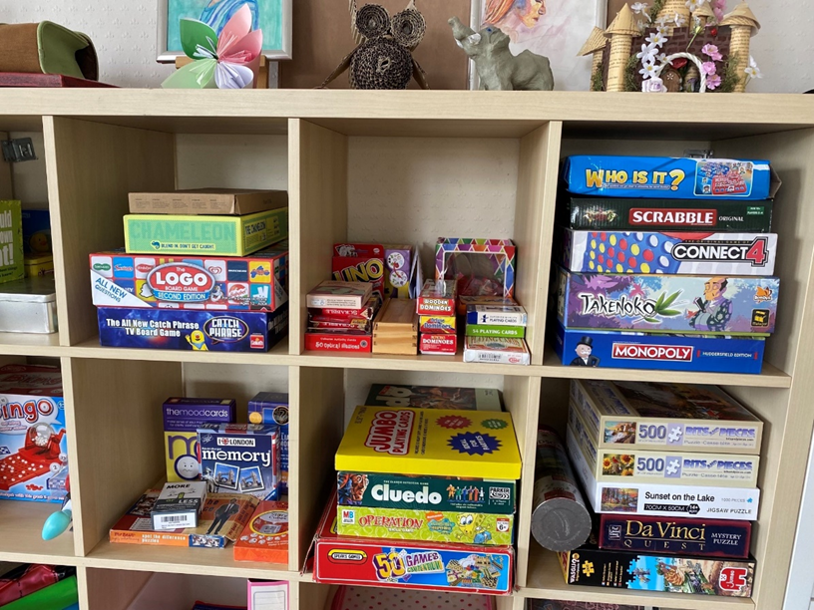

Creative Weekends



Come join us for our Creative Weekends including Board Games, Movies and Arts and Crafts.

**Drop-in times:**

**SATURDAYS** @ Huddersfield office – **11am till 1pm** and **2pm till 4pm**

**SUNDAYS** @ Dewsbury Office -**11am till 1pm** and

**1.30 – 3.30pm**

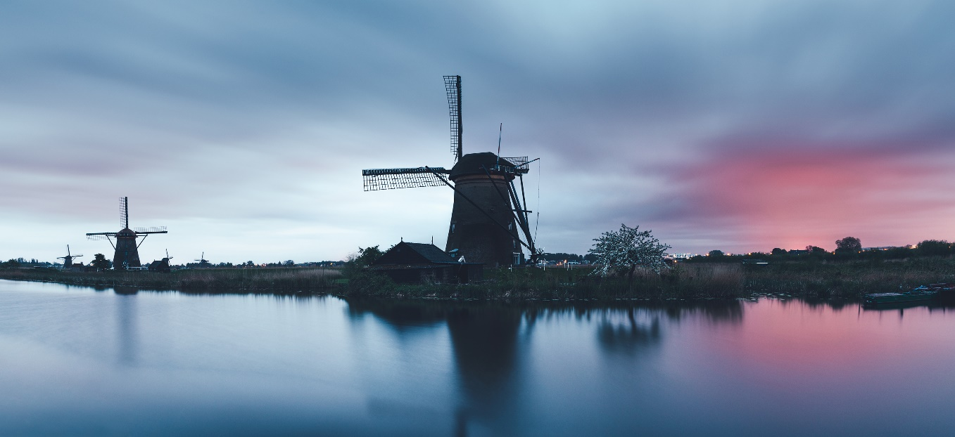



|  |  |  |  |  |  |  |
| --- | --- | --- | --- | --- | --- | --- |
| **Social Media**  **Follow us on:**  Instagram: @Clear_Kirklees  Twitter:  CL Kirklees  www.facebook.com/  CommunityLinks |  |  |  | **Attic Stories/ Open poetry**  **Mic Night –**  **25th April**  Listen, participate or ponder the wisdom of the spoken word! |  |  |
|  |  |  |  |  |  |  |
|  |  | **Fri-da Mind**  **(Art session)**  **6th June**  **Frida Kahlo inspired artistic session – all abilities welcome** |  |  |  | **Yoga -22/4/2022**  Learn to bend in the breeze/ Chanel your inner Lotus! |
|  |  |  |  |  |  |  |
|  |  |  |  | **Gardening Course – 29th April – 20th May**  Practical tips to put a spring in your step! |  |  |
|  |  |  |  |  |  |  |

**BARGE TRIP**

25th April

Meandering in the midday sun on the quiet canals of England. (See poster)





**Clear Huddersfield**

32-34 Lion Chambers, John William Street, Huddersfield, HD1 1ES

01484 519 097

[clear.huddersfield@commlinks.co.uk](mailto:clear.huddersfield@commlinks.co.uk)

**Clear Dewsbury**

26 Bond Street, Dewsbury, WF13 1AU

01924 465 054

[clear.dewsbury@commlinks.co.uk](mailto:clear.dewsbury@commlinks.co.uk)



