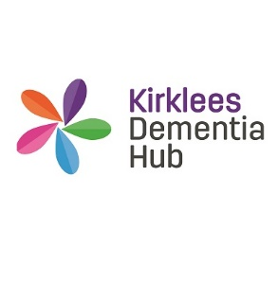

ROLE DESCRIPTION

ROLE: | Administration Volunteer
ACCOUNTABLE TO: | Kirklees Dementia Hub Coordinator
H HOURS: | Flexible
LOCATION: | 32-34 Lion Chambers, John William Street, HD1 1ES
EXPERIENCE: | No specific experience is required
COMMITMENT: | Time commitment is flexible for this role

Would you like to help support the local community to live well with dementia? Have you got great communication skills and are adaptable to the needs of others? Kirklees Dementia Hub are looking for volunteers to help deliver this service.

KIRKLEES DEMENTIA HUB (KDH)
KDH is a partnership between Community Links and Age UK Calderdale & Kirklees and offers an information, advice and signposting service for anyone living in Kirklees diagnosed with dementia, and their friends, family and carers.
ABOUT THE ROLE
KDH is committed to providing up to date and relevant information on services and items of interest to people affected by dementia, to support their personal plan.
OUTLINE OF ROLE:
As a volunteer you would be supporting KDH staff with the administration needs of the service.
MAIN TASKS:
- Database administration
- Composing Letters
- Printing flyers, leaflets and letters
- Putting together welcome packs
- Photocopying
- To carry out any other duties which may be required and are consistent with the role in agreement with the volunteer coordinator

THE IDEAL VOLUNTEER WILL HAVE
Essential
- Good communication as well as active listening skills
- Flexible and cooperative response to working in a team
- Good interpersonal skills
- Can demonstrate empathy and compassion
- Honest and reliable with a pleasant and friendly manner

Desirable
- Awareness or interest in learning about dementia
- Enjoy meeting people.

Behaviours and values
- Willingness to understand the issues and barriers related to people affected by dementia
- An open-minded approach to individuals, avoiding judgement and stereotyping.
- Enjoy working with others.
- A commitment to and understanding of equal opportunities.
- Patient and understanding.
- Ability to work as a team player and a positive approach to supervision.

TRAINING AND SUPERVISION:

In house training and guidance will be provided during your Induction Period. We also provide ongoing learning and development throughout your volunteer experience along with regular supervision.

BENEFITS TO YOU:
- We will make you feel welcome, included and respected
- Receive one to one and group-based support
- Access to Induction, Learning, Development and Engagement.
- Gain practical skills and experience
- Join a great team of like-minded people
- Enhance your CV
- Expenses reimbursed as agreed with the hub coordinator

Interested?

Please contact Charlene on 07387 019 180 for more information and to arrange an informal chat:

We look forward to hearing from you!

