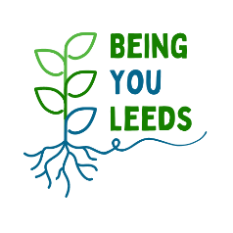
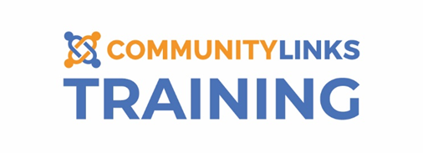

Training Booking Form

If you would like to register for Being You Leeds training provided by Community Links Training Team, please complete the form below and return to training@commlinks.co.uk . The data you provide will remain safe and secure in accordance with law (GDPR).
Please visit https://www.inspirenorth.co.uk/privacy-policy/ to view our privacy policy.

Full Name
This training is being funded by Being You Leeds to increase access to Mental Health Training for:
- community organisations, charities and non-profit organisations
- volunteers as well as paid workers
We are keen to ensure that those attending either work or volunteer for:
- organisations working within the most deprived areas of Leeds or
- organisations supporting socially excluded groups and communities with the worst health outcomes
To qualify for a free place, you must also be (working or volunteering) directly supporting people.
If you are not sure if you qualify, please read our attached FAQ or you can call Community Links on 0113 273 9660 or Being You Leeds on 0113 248 4880.
Please confirm you meet the criteria above | Yes ☐ | No ☐
 | If you have ticked YES, please complete the rest of this registration form
Organisation
Name
Please tell us, in a few words, who your organisation supports (e.g people living in a certain area, refugees and asylum seekers, pregnant women, people in debt etc.):

Please tell us where you heard about the course:

Role | Volunteer ☐ | Paid worker ☐
Course | SafeTALK ☐  Mental Health First Aid (MHFA) ☐  ASIST ☐
Preferred
Date(s)
Access needs - Please let us know if there are any adjustments we can make to help you access this course more easily. These could be physical, sensory or health needs, learning needs or communication needs and can apply to travel, building and room access and course content and delivery:

We ask the following questions as part of our commitment to diversity and inclusion. We use this data to identify groups that may be underrepresented or disadvantaged, and this helps us take appropriate steps to avoid discrimination and improve equality and diversity. Any monitoring shall be done in accordance with the organisation’s obligations under GDPR. Providing this information is voluntary. If you do not wish to answer any question you may select the 'prefer not to say' option.
Gender | Female (including trans women) ☐ Male (including trans man) ☐ Non-Binary ☐
 | Prefer Not to Say ☐ Other (please state):
Ethnicity | White
 | ☐ English / Welsh / Scottish / Northern Irish / British
 | ☐ Irish ☐ Any other White background
 | Mixed
 | ☐ White & Asian ☐ White & Black Caribbean
 | ☐ White & Black African ☐ Other Mixed background
 | Asian/Asian British
☐ Bangladeshi ☐ Chinese ☐ Kashmiri ☐ Indian ☐ Pakistani
☐ Other Asian background
 | Black/Black British
 | ☐ Black African ☐ Black Caribbean ☐ Other Black background
 | Other Ethnic Groups
 | ☐ Middle Eastern/Arab ☐ Roma ☐ Gypsy/Traveller
 | ☐ Any other Ethnic background
Sexuality | ☐ Straight / Heterosexual ☐ Gay man ☐ Lesbian / Gay woman  ☐ Bisexual / Pansexual ☐ Other ☐ Prefer not to say
Religion | Buddhist ☐ Christian ☐ Hindu ☐ Jewish ☐ Muslim ☐ Sikh ☐ No Religion ☐
 | Prefer not to say ☐ Other (please state):
Disability | ☐ Learning disability ☐ Physical disability ☐ Mental Health  ☐ Visual Impairment ☐ Hearing Impairment ☐ Neurodiversity  ☐ Longstanding illness/condition ☐ Prefer not to say ☐ None

