

|  |  |  |  |  |  |  |
| --- | --- | --- | --- | --- | --- | --- |
| Mon | Tue | Wed | Thu  January 2020 | Fri | Sat | Sun |

|  |  |  |  |  |  |  |
| --- | --- | --- | --- | --- | --- | --- |
| **30 DEWS**  **10-1 Crow’s Nest Park Winter Walk** | **31 HUDDS**  **1-4 Social Drop In**  **Service closed from 5pm** | **1**  **New Year’s Day Service Closed** | **2**  **5.30-7.30** **Men’s Group** | **3**  **1-3** Women’s Social | **4**  **11-1** Creative Saturday Hudd  **Service Closed 1-2**  **2-4** Films/Games/Art | **5**  **11-1** Creative Sunday  **11.30 -12.30** **Words in Mind (see poster)**  **Service closed 1-1.30**  **1.30-3.30** Films/Games/Art |
| **6**  **1-3 Light Therapy Drop in (see poster)**  **4.30-6.30** Meditation Mondays | **7**  **1.30 -3.30** Make Space  **4-6** Creative Writing | **8**  **10-12** Prism Group  **10-1** Allotment (H)  **5.30-7.30** Men’s Group | **9**  **1-3.30 All Together’s Films, Chat and Snacks (see poster)** | **10**  **10.30-2.30** Waterside Wellbeing  **1-3** Women’s Social | **11**  **11-1** Creative Saturday Hudd  **Service Closed 1-2**  **2-4** **IQ Games - Hudds** | **12**  **11-1** Creative Sunday  **11.30 -12.30** Words in Mind  **Service closed 1-1.30**  **1.30-3.30** Films/Games/Art |
| **13**  **1-3** Light Therapy Drop in  **4.30-6.30** Meditation Mondays | **14**  **1.30 -3.30** Make Space  **4-6** Creative Writing | **15**  **10-12** Prism Group  **10-1** Allotment (H)  **5.30-7.30** Men’s Group | **16**  **11-1 WRAP Session (see poster)**  **1-3** Mystery History | **17**  **1-3** Women’s Social | **18**  **11-1** Creative Saturday Hudd  **Service Closed 1-2**  **2-4** Films/Games/Art | **19**  **11-1** Creative Sunday  **11.30 -12.30** Words in Mind  **Service closed 1-1.30**  **1.30-3.30** Films/Games/Art |
| **20**  **1-3** Light Therapy Drop in  **4.30-6.30** Meditation Mondays | **21**  **1.30 -3.30** Make Space  **4-6** Creative Writing | **22**  **10-12** Prism Group  **10-1** Allotment (H)  **5.30-7.30** Men’s Group | **23**  **1-3** Show and Tell | **24**  **10.30-2.30** Waterside Wellbeing  **1-3** Women’s Social | **25**  **11-1** Creative Saturday Hudd  **Service Closed 1-2**  **2-4** **IQ Games - Hudds** | **26**  **11-1** Creative Sunday  **11.30 -12.30** Words in Mind  **Service closed 1-1.30**  **1.30-3.30** Films/Games/Art |



February 2020

|  |  |  |  |  |  |  |
| --- | --- | --- | --- | --- | --- | --- |
| Mon | Tue | Wed | Thu | Fri | Sat | Sun |
| **27**  **1-3** Light Therapy Drop in  **4.30-6.30** Meditation Mondays | **28**  **1.30 -3.30** Make Space  **4-6** Creative Writing | **29**  **10-12** Prism Group  **10-1** Allotment (H)  **5.30-7.30** Men’s Group | **30**  **1-3** Mystery History | **31**  **1-3** Women’s Social  **1-3 Devising Poetry (see poster)** | **1**  **11-1** Creative Saturday Hudd  **1-2 Service closed**  **2-4** Free Time Films/Games/Art | **2**  **11-1** Creative Sunday  **11.30 -12.30** Words in Mind  **Service closed 1-1.30**  1.30-3.30 Free Time Films/Games/Art |
| **3**  **1-3** Light Therapy Drop in  **4.30-6.30** Meditation Mondays | **4**  **1.30 -3.30** Make Space  **4-6** Creative Writing | **5**  **10-12** Prism Group  **10-1** Allotment (H)  **5.30-7.30** Men’s Group | **6**  **1-3** Show and Tell | **7**  **1-3** Women’s Social  **11-1 Bean Bags and Biscuits (see poster)** | **8**  **11-1** Creative Saturday Hudd  **1-2 Service closed**  **2-4**  **IQ Games - Hudds** | **9**  **11-1** Creative Sunday  **11.30 -12.30** Words in Mind  **Service closed 1-1.30**  **1.30-3.30** Films/Games/Art |
| **10**  **1-3** Light Therapy Drop in  **4.30-6.30** Meditation Mondays | **11**  **1.30 -3.30** Make Space  **4-6** Creative Writing | **12**  **10-12** PrismGroup  **10-1** Allotment (H)  **5.30-7.30** Men’s Group | **13**  **Mystery History- Cancelled** | **14**  **1-3** Women’s Social  **1-4 All Together’s Quizzes and prizes (see poster)** | **15**  **11-1** Creative Saturday Hudd  **1-2 Service closed**  **2-4** Films/Games/Art | **16**  **11-1** Creative Sunday  **11.30 -12.30** Words in Mind  **Service closed 1-1.30**  **1.30-3.30** Films/Games/Art |
| **17**  **1-3** Light Therapy Drop in  **4.30-6.30** Meditation Mondays | **18**  **1.30 -3.30** Make Space  **4-6** Creative Writing | **19**  **10-12** Prism Group  **10-1** Allotment (H)  **5.30-7.30** Men’s Group | **20**  **1-3** Show and Tell | **21**  **11-1 Brain in Hand Drop in**  **1-3** Women’s Social | **22**  **11-1** Creative Saturday Hudd  **1-2 Service closed**  **2-4**  **IQ Games - Hudds** | **23**  **11-1** Creative Sunday  **11.30 -12.30** Words in Mind  **Service closed 1-1.30**  1**.30-3.30** Films/Games/Art |
| **24**  **1-3** Light Therapy Drop in  **4.30-6.30** Meditation Mondays | **25**  **1.30 -3.30** Make Space  **4-6** Creative Writing | **26**  **Service closed – Staff Training** | **27**  **1-3** Mystery History | **28**  **1-3** Women’s Social  **1-3** **Devising Poetry** | **29**  **11-1** Creative Saturday Hudd  **1-2 Service closed**  **2-4** Films/Games/Art | **1**  **11-1** Creative Sunday  **11.30 -12.30** Words in Mind  **Service closed 1-1.30**  **1.30-3.30** Films/Games/Art |

**Where are we located?**

**The clear service provides support for people in Kirklees with a range of mental health needs, including Dementia to reach their goals and aspirations.**

**We support people to identify how they can progress on their recovery journey and provide a range of social, leisure and skills based activities which support self-help, wellbeing and recovery. . . .**

**Clear has bases in both Huddersfield and Dewsbury but also provides many community based activities.**

**Please let staff know if you have any special requirements.**

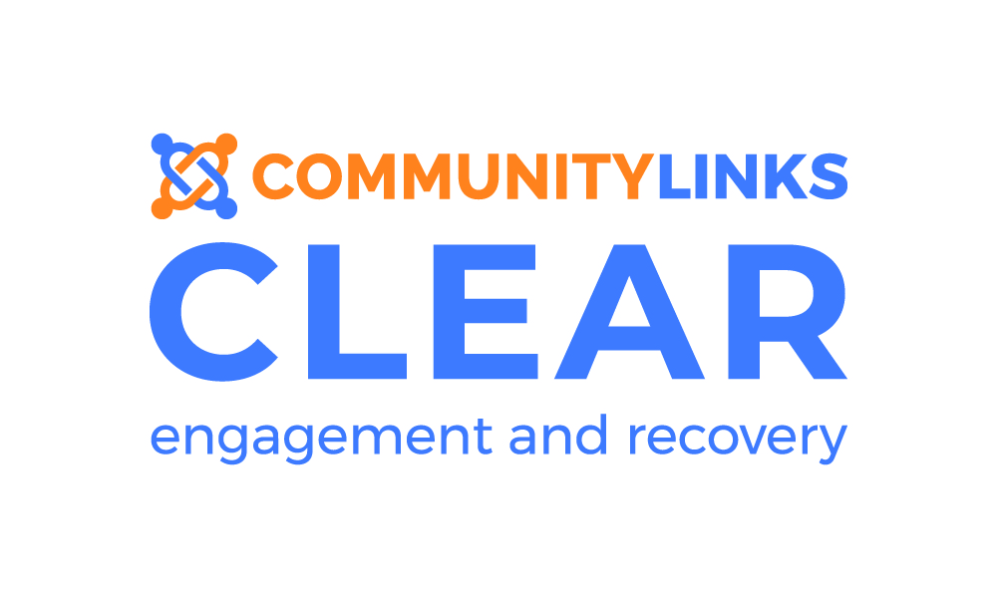



**DEWSBURY TIMETABLE**

**January – March 2020**

**Dewsbury**

26 Bond Street

Dewsbury

WF13 1AU

Telephone: 01924 465 054

Email: clear.dewsbury@commlinks.co.uk

Website: [www.commlinks.co.uk](http://www.commlinks.co.uk)

* **For the full group or course information please see the itineraries on the notice board in reception.**
* **Courses are not found on the timetable. Please book onto a course via your Key Worker. Courses we currently run are; Mindfulness, Sleep, Anxiety Management, Anger Management and Wellbeing Skills.**
* **Trips and one off events are highlighted in Blue look out for posters with more information.**
* **Bank Holidays, closures, team meetings or group cancellations in Green**

**How do I access the service?**

You can self-refer or a professional can refer on your

behalf.

Send your referral by email, post or drop off in person

**What happens when you receive my referral?**

Once your referral has been received by CLEAR,

you will be sent out a letter for an initial assessment

with your keyworker. This will be within 10 days.



March 2020



|  |  |  |  |  |  |  |
| --- | --- | --- | --- | --- | --- | --- |
| Mon | Tue | Wed | Thu | Fri | Sat | Sun |
| 2  **1-3** Light Therapy Drop in  **4.30-6.30** Meditation Mondays | **3**  **1.30 -3.30** Make Space  **4-6** Creative Writing | **4**  **10-12** Prism Group  **10-1** Allotment (H)  **5.30-7.30** Men’s Group | **5**  **1-3** Show and Tell | **6**  **11- 4pm International Women’s Day Celebration (See poster)** | **7**  **11-1** Creative Saturday Hudd  **1-2 Service closed**  **2-4** **IQ Games - Hudds** | **8**  **11-1** Creative Sunday  **11.30 -12.30** Words in Mind  **Service closed 1-1.30**  **1.30-3.30** Films/Games/Art |
| **9**  **1-3** Light Therapy Drop in  **4.30-6.30** Meditation Mondays | **10**  **1.30 -3.30** Make Space  **4-6** Creative Writing | **11**  **10-12** Prism Group  **10-1** Allotment (H)  **5.30-7.30** Men’s Group | **12**  **1-3** Mystery History | **13**  **1-3** Women’s Social | **14**  **11-1** Creative Saturday Hudd  **1-2 Service closed**  **2-4** Films/Games/Art | **15**  **11-1** Creative Sunday  **11.30 -12.30** Words in Mind  **Service closed 1-1.30**  **1.30-3.30** Films/Games/Art |
| **16**  1-3 Light Therapy Drop in  **4.30-6.30** Meditation Mondays | **17**  **1.30 -3.30** Make Space  **4-6** Creative Writing | **18**  **10-12** Prism Group  **10-1** Allotment (H)  **5.30-7.30** Men’s Group | **19**  **1-3** Show and Tell | **20**  **11-4 All Together’s Bowling @ Super Bowl (H) (see poster)**  **1-3** Women’s Social | **21**  **11-1** Creative Saturday Hudd  **1-2 Service closed**  **2-4** **IQ Games - Hudds** | **22**  **11-1** Creative Sunday  **Service closed 1-1.30**  **1.30-3.30** Films/Games/Art |
| **23**  **1-3** Light Therapy Drop in  **4.30-6.30** Meditation Mondays | **24**  **1.30 -3.30** Make Space  **4-6** Creative Writing | **25**  **10-12** Prism Group  **10-1** Allotment (H)  **5.30-7.30** Men’s Group | **26**  **11-3 History Museum trip (see poster)** | **27**  **1-3** Women’s Social  **1-3** **Devising Poetry** | **28 11-1** Creative Saturday Hudd  **1-2 Service closed**  **2-4** Films/Games/Art | **29**  **11-1** Creative Sunday  **11.30 -12.30** Words in Mind  **Service closed 1-1.30**  **1.30-3.30** Films/Games/Art |
| **30**  **1-3** Light Therapy Drop in  **4.30-6.30** Meditation Mondays | **31**  **1.30 -3.30** Make Space  **4-6** Creative Writing | **1**  **10-12** Prism Group  **10-1** Allotment (H)  **5.30-7.30** Men’s Group | **2**  **1-3** Show and Tell | **3**  **1-3** Women’s Social | **4**  **11-1** Creative Saturday Hudd **1-2 Service closed**  **2-4** **IQ Games - Hudds** | **5**  **11-1** Creative Sunday  **Service closed 1-1.30**  **1.30-3.30**Films/Games/Art |