

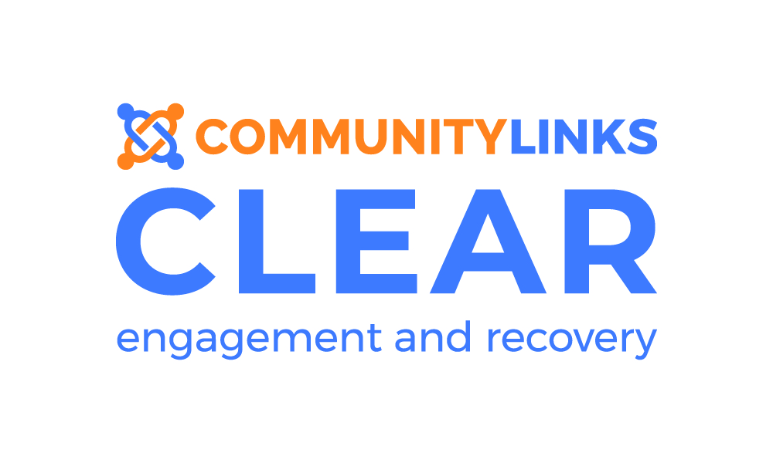

|  |  |  |  |  |  |  |
| --- | --- | --- | --- | --- | --- | --- |
| Mon | Tue | Wed | Thu  October 2019 | Fri | Sat | Sun |

|  |  |  |  |  |  |  |
| --- | --- | --- | --- | --- | --- | --- |
| **30**  **10-12** Women’s Social  **1-3** All Together  **4.30-6.30** Meditation Mondays | **1**  **1.30 -3.30 Make Space (see poster)**  **4-6** Creative Writing | **2**  **10-1** Allotment (H)  **5.30-7.30** Men’s Group | **3**  **11-4** **Poetry in the Park@ Greenhead Park (see poster)** | **4**  **10.30-2.30** Waterside Wellbeing | **5**  **11-1** Creative Saturday Hudd  **Service Closed 1-2**  **2-4** Free Time Films/Games/Art | **6**  **11-1** Creative Sunday  **Service closed 1-1.30**  **1.30-3.30 Free Time Films/Games/Art** |
| **7**  **10-12** Women’s Social  **1-3** All Together  **4.30-6.30** Meditation Mondays | **8**  **10.30-1.30** **Morning Meditation @ Allotment (see poster)**  **1.30 -3.30** Make Space  **4-6** Creative Writing | **9**  **10-1** Allotment (H)  **5.30-7.30** Men’s Group | **10**  **11-2 World Mental Health Day** **Brunch drop in (see poster)** | **11**  **10.30-2.30** Waterside Wellbeing  **11-1** Project Planning session (see poster) | **12**  **11-1** Creative Saturday Hudd  **Service Closed 1-2**  **2-4** Free Time Films/Games/Art | **13**  **11-1** Creative Sunday  **Service closed 1-1.30**  **1.30-3.30 Free Time Films/Games/Art** |
| **14**  **10-12** Women’s Social  **1-3** All Together  **4.30-6.30** Meditation Mondays | **15**  **1.30 -3.30** Make Space  **4-6** Creative Writing | **16**  **10-1** Allotment (H)  **5.30-7.30** Men’s Group | **17**  **Service Closed – Staff Away Day** | **18**  **10.30-2.30** Waterside Wellbeing | **19**  **11-1** Creative Saturday Hudd  **Service Closed 1-2**  **2-4** Free Time Films/Games/Art | **20**  **11-1** Creative Sunday  **Service closed 1-1.30**  **1.30-3.30** Free Time Films/Games/Art |
| **21**  **10-12** Women’s Social  **1-3** All Together  **4.30-6.30** Meditation Mondays | **22**  **1.30 -3.30** Make Space  **2-3 Healthy Minds (H) (see poster)**  **4-6** Creative Writing | **23**  **10-1** Allotment (H)  **5.30-7.30** Men’s Group | **24** | **25**  **10.30-2.30** Waterside Wellbeing | **26**  **11-1** Creative Saturday Hudd  **Service Closed 1-2**  **2-4** Free Time Films/Games/Art | **27**  **11-1** Creative Sunday  **Service closed 1-1.30**  **1.30-3.30** Free Time Films/Games/Art |



November 2019



|  |  |  |  |  |  |  |
| --- | --- | --- | --- | --- | --- | --- |
| Mon | Tue | Wed | Thu | Fri | Sat | Sun |
| **28**  **10-12** Women’s Social  **1-3** All Together  **4.30-6.30** Meditation Mondays | **29**  **1.30 -3.30** Make Space  **2-3 Healthy Minds (H)**  **4-6** Creative Writing | **30**  **10-12 Prism peer support (see poster)**  **10-1** Allotment (H)  **5.30-7.30** Men’s Group | **31**  **10-12 Pumpkin Carving (H) (see poster)** | **1**  **10.30-2.30** Waterside Wellbeing | **2**  **11-1** Creative Saturday Hudd  **1-2 Service closed**  **2-4** Free Time Films/Games/Art | **3**  **11-1** Creative Sunday  **Service closed 1-1.30**  1.30-3.30 Free Time Films/Games/Art |
| **4**  **10-12** Women’s Social  **1-3** All Together  **4.30-6.30** Meditation Mondays | **5**  **1.30 -3.30** Make Space  **2-3 Healthy Minds (H)**  **4-6** Creative Writing | **6**  **10-12 Prism**  **10-1** Allotment (H)  **5.30-7.30** Men’s Group | **7**  **11-1 WRAP Session**  **(see poster)** | **8**  **10.30-2.30** Waterside Wellbeing | **9**  **11-1** Creative Saturday Hudd  **1-2 Service closed**  **2-4** Free Time Films/Games/Art | **10**  **11-1** Creative Sunday  **Service closed 1-1.30**  **1.30-3.30** Free Time Films/Games/Art |
| **11**  **10-12** Women’s Social  **1-3** All Together  **4.30-6.30** Meditation Mondays | **12**  **1.30 -3.30** Make Space  **2-3 Healthy Minds (H)**  **4-6** Creative Writing | **13**  **10-12 Prism**  **10-1** Allotment (H)  **5.30-7.30** Men’s Group | **14** | **15**  **10.30-2.30** Waterside Wellbeing | **16**  **11-1** Creative Saturday Hudd  **1-2 Service closed**  **2-4 Board Games at IQ Hudds** | **17**  **11-1** Creative Sunday  **Service closed 1-1.30**  **1.30-3.30** Free Time Films/Games/Art |
| **18**  **10-12** Women’s Social  **1-3** All Together  **4.30-6.30** Meditation Mondays | **19**  **1.30 -3.30** Make Space  **2-3 Healthy Minds (H)**  **4-6** Creative Writing | **20**  **10-12 Prism**  **10-1** Allotment (H)  **5.30-7.30** Men’s Group | **21**  **1-3 Mystery History (see poster)** | **22**  **10.30-2.30** Waterside Wellbeing | **23**  **11-1** Creative Saturday Hudd  **1-2 Service closed**  **2-4** Free Time Films/Games/Art | **24**  **11-1** Creative Sunday  **Service closed 1-1.30**  1**.30-3.30** Free Time Films/Games/Art |
| **25**  **10-12** Women’s Social  **1-3** All Together  **4.30-6.30** Meditation Mondays | **26**  **1.30 -3.30** Make Space  **2-3 Healthy Minds (H)**  **4-6** Creative Writing | **27**  **10-12 Prism**  **10-1** Allotment (H)  **5.30-7.30** Men’s Group | **28**  **1-3 Show and Tell (see poster)** | **29**  **10.30-2.30** Waterside Wellbeing | **30**  **11-1** Creative Saturday Hudd  **1-2 Service closed**  **2-4** Free Time Films/Games/Art | **1**  **11-1** Creative Sunday  **Service closed 1-1.30**  **1.30-3.30** Free Time Films/Games/Art |

**Where are we located?**

**The clear service provides support for people in Kirklees with a range of mental health needs, including Dementia to reach their goals and aspirations.**

**We support people to identify how they can progress on their recovery journey and provide a range of social, leisure and skills based activities which support self-help, wellbeing and recovery. . . .**

**Clear has bases in both Huddersfield and Dewsbury but also provides many community based activities.**

**Please let staff know if you have any special requirements.**





**DEWSBURY TIMETABLE**

**October - December 2019**

**Dewsbury**

26 Bond Street

Dewsbury

WF13 1AU

Telephone: 01924 465 054

Email: clear.dewsbury@commlinks.co.uk

Website: [www.commlinks.co.uk](http://www.commlinks.co.uk)

* **For the full group or course information please see the itineraries on the notice board in reception.**
* **Courses are not found on the timetable. Please book onto a course via your Key Worker. Courses we currently run are; Mindfulness, Sleep, Anxiety Management, Anger Management and Wellbeing Skills.**
* **Trips and one off events are highlighted in Blue look out for posters with more information.**
* **Bank Holidays, closures, team meetings or group cancellations in Green**

**How do I access the service?**

You can self-refer or a professional can refer on your

behalf.

Send your referral by email, post or drop off in person

**What happens when you receive my referral?**

Once your referral has been received by CLEAR,

you will be sent out a letter for an initial assessment

with your keyworker. This will be within 10 days.





December 2019

|  |  |  |  |  |  |  |
| --- | --- | --- | --- | --- | --- | --- |
| Mon | Tue | Wed | Thu | Fri | Sat | Sun |
| 2  **10-12** Women’s Social  **1-3** All Together  **4.30-6.30** Meditation Mondays | **3**  **1.30 -3.30** Make Space  **4-6** Creative Writing | **4**  **10-12 Prism**  **10-1** Allotment (H)  **5.30-7.30** Men’s Group | **5**  **1-3** Mystery History | **6**  **1-**3 **Bean Bags and Biscuits (see poster)** | **7**  **11-1** Creative Saturday Hudd  **1-2 Service closed**  **2-4** Free Time Films/Games/Art | **8**  **11-1** Creative Sunday  **Service closed 1-1.30**  **1.30-3.30** Free Time Films/Games/Art |
| **9**  **10-12** Women’s Social  **1-3** All Together  **4.30-6.30** Meditation Mondays | **10**  **1.30 -3.30** Make Space  **4-6** Creative Writing | **11**  **Clear’s Christmas Party**  **(see poster)** | **12**  **1-3** Show and Tell  **5.30-7.30 Men’s group** | **13** | **14**  **11-1** Creative Saturday Hudd  **1-2 Service closed**  **2-4** Free Time Films/Games/Art | **15**  **11-1** Creative Sunday  **Service closed 1-1.30**  **1.30-3.30** Free Time Films/Games/Art |
| **16**  **10-12** Women’s Social  **1-3** All Together  **4.30-6.30** Meditation Mondays | **17**  **1.30 -3.30** Make Space  **4-6** Creative Writing | **18**  **Service Closed from 12pm for Staff away day** | **19**  **11-2** **Brunch drop in**  **1-3** Mystery History  **5.30-7.30 Men’s group** | **20** | **21**  **11-1** Creative Saturday Hudd  **1-2 Service closed**  **2-4** Free Time Films/Games/Art | **22**  **11-1** Creative Sunday  **Service closed 1-1.30**  **1.30-3.30** Free Time Films/Games/Art |
| **23 HUDDS**  **2-4 Board Games** | **24 DEWS**  **11-2 Film**  **Service closed from 5pm** | **25**  **Christmas Day – Service Closed** | **26**  **Boxing Day - Service closed** | **27 HUDDS**  **10-1 Greenhead Park Winter walk** | **28**  **11-1** Creative Saturday Hudd  **1-2 Service closed**  **2-4** Free Time Films/Games/Art | **29**  **11-1** Creative Sunday  **Service closed 1-1.30**  **1.30-3.30** Free Time Films/Games/Art |
| **30 DEWS**  **10-1 Crow’s Nest Park Winter Walk** | **31 HUDDS**  **1-4 Social Drop In**  **Service closed from 5pm** | **1**  **New Year’s Day – Service Closed** | **2**  **5.30-7.30 Men’s group** | **3** | **4**  **11-1** Creative Saturday Hudd  **1-2 Service closed**  **2-4** Free Time Films/Games/Art | **5**  **11-1** Creative Sunday  **Service closed 1-1.30**  **1.30-3.30** Free Time Films/Games/Art |