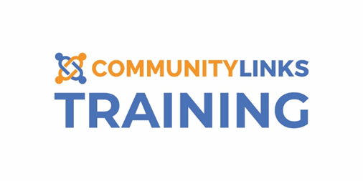
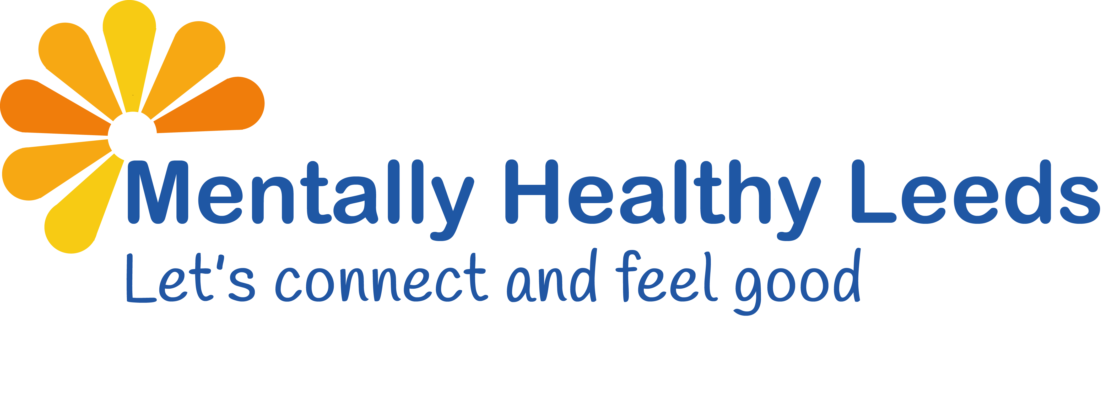
Training Booking Form

If you would like to register for Mentally Healthy Leeds (MHL) provided by Community Links Training Team, please complete the form below and return to training@commlinks.co.uk The data you provide will remain safe and secure in accordance with law (GDPR).
Please visit https://www.inspirenorth.co.uk/privacy-policy/ to view our privacy policy.

Name
Organisation
Course | Mental Health First Aid (MHFA) ☐  ASIST ☐  LivingWorks START ☐  safeTALK ☐
Preferred Date (s)
Only for MHFA please provide the address you would like your manual posted to
Please confirm you meet the criteria to access MHL training | FREE to all frontline workers in Leeds including volunteers and peer mentors  Yes ☐  No ☐
We ask the below questions as part of our commitment to diversity and inclusion to ensure that our policy is operating effectively and to identify groups that may be underrepresented or disadvantaged. Analysing this data helps us take appropriate steps to avoid discrimination and improve equality and diversity. Any monitoring shall be done in accordance with the organisation’s obligations under GDPR.
Providing this information is voluntary. If you do not wish to answer any question you may select the 'prefer not to say' option.
Gender | Female (including trans women) ☐ Male (including trans man) ☐ Non-Binary ☐
 | Prefer Not to Say ☐ Other (please state):
Ethnicity | Asian
 | Bangladeshi ☐ Chinese ☐ Kashmiri ☐ Indian ☐ Pakistani ☐
 | Any other Asian background (please state):
 | Black
African ☐ Black British ☐ Caribbean ☐
Any other Black background (please state):
 | Mixed
 | Black & Asian ☐ White & Asian ☐ White & Black Caribbean ☐
 | White & Black African ☐ Any other Mixed background (please state):
 | White
White British ☐ Irish ☐ Gypsy/Traveller ☐
Any other White background (please state):
 | Other Ethnic Groups
 | Middle Eastern ☐ Any other Ethnic background (please state):
 | Prefer not to say ☐
Sexuality | Bisexual ☐ Gay ☐ Heterosexual ☐ Lesbian ☐ Prefer not to say ☐
 | Other (please state):
Religion | Buddhist ☐ Christian ☐ Hindu ☐ Jewish ☐ Muslim ☐ Sikh ☐ No Religion ☐
 | Prefer not to say ☐ Other (please state):
Residency | British Citizen ☐ EU National ☐ Refugee ☐ Destitute ☐ Asylum Seeker ☐ Foreign Student ☐ Prefer not to say ☐ Other (please state):
Disability | Learning ☐ Physical ☐ Sensory ☐ Mental Health ☐ None ☐
 | Prefer not to say ☐
 | If you have ticked Learning, Physical, Sensory, and/or Mental Health above please provide further information and state any reasonable adjustments you may need below:
Do you require support with communication? |  | Yes ☐ No ☐
If yes, please state what support you require:

