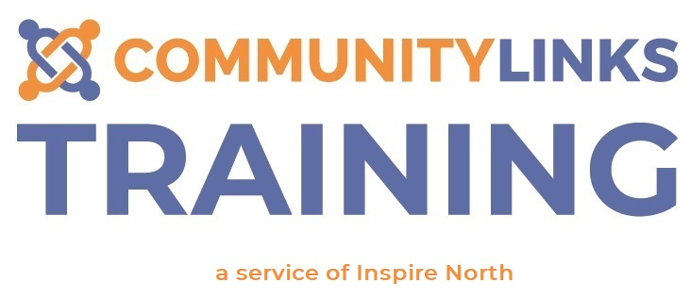
Training Terms & Conditions
Our Promises to you

Administration
- Your calls and emails will be answered promptly during office hours. Please allow 2-3 working days for booking requests and non-urgent communications.
- Your enquiries will be handled professionally and courteously by our training administrators
- Any additional needs will be understood and met as far as possible
- Joining instructions will be sent to you at least 2 weeks prior to your course
- Where we are responsible for certification, we will issue your certificate within one month of attending your course

Training
- Your training course will start and finish on time
Your trainer will be professional, courteous and approachable
- You will be asked to leave the training and rebook onto another session if you have not completed any pre-requisite course tasks. This will be at the trainer’s discretion
- Your trainer will respond to your individual learning needs
- The content of your course will be current, well-researched and evidence based
- Community Links service users will contribute to the development and delivery of our courses
- We will use your feedback to continuously improve our courses

Feedback
- All feedback is welcomed
- We will make every effort to contact you regarding your feedback within 2 working days
- We will work with you to resolve the issue
- We will take responsibility and be proactive in the resolution of the problem
- We will ensure that as far as possible you are happy with the outcome

Please note that if you cancel the course within 14 days prior to the training, you will be charged for the full cost of the course. If you cancel before the 14 day period, it is within our discretion to charge an administration fee of £25, which will be deducted from your course refund.

