

01904 637233

yorkhousingsupport@commlinks.co.uk

Facebook.com/CommunityLinks

@CLYork4

Instagram.com/clinksyork/

Commlinksnorth

www.commlinks.co.uk/yhws

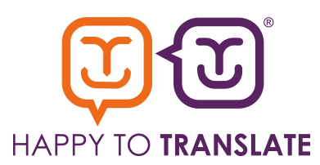

You can translate the information on our website into a range of languages.

Visit www.commlinks.co.uk and click on the ‘Select Languages’ option which appears on the top left.

If you need this information in another language or format, please contact us.

Company No. 1657651 Charity Commission Registered No. 514779

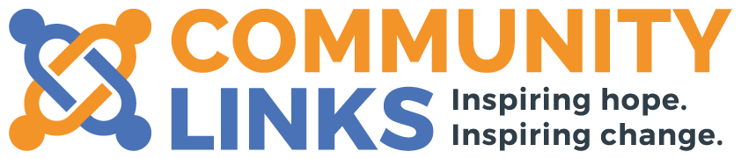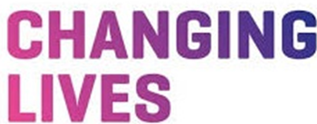

YORK HOUSING

WELLBEING SERVICE

**Supporting people to**

**keep their homes**

**Community Links is a mental health charity pioneering a wide range of mental health and housing services across Yorkshire and the Humber, and is a part of the Inspire North Charity Group.**

**In partnership with**



* Addressing debt and budgeting issues
* Dealing with Anti-social Behaviour
* Claiming the correct benefits
* Accessing training, education and employment
* Social isolation
* Accessing physical or mental health support

**We offer support with the following:**

The York Housing Wellbeing service provides flexible, creative, responsive housing and mental health support to adults in the community. We do this by supporting and enabling people to meet their day-to-day housing, health and financial needs.

**About the service:**

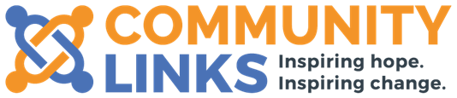



All referrals are received through the York Single Access Point at City of York Council.

Please contact us on 01904 637233 for further information or visit our website: www.commlinks.co.uk/yhws to download the referral form.

**How do I access the service?**

The service is suitable for any person/couple over 16 years of age struggling with housing-related issues or whose circumstances are having a negative impact on their housing and wellbeing.

**Who is the service for?**