Client

Handbook

COMMUNITY LINKS
FLOATING SUPPORT
www.commlinks.co.uk

@CL_York

v.2 Feb 2022

Contents
Introduction to Community Links | 2
Road to Recovery | 3
Housing Support Worker Role | 5
Support Agreement | 7
Confidentiality | 7
Accessing Your Information | 7
Diversity | 8
Boundaries | 9
Your Rights | 9
What We Expect From You | 10
Safeguarding | 10
Smoking, Drugs & Alcohol | 11
Client Involvement & Co-production | 12
Advocacy | 12
Compliments, Complaints & Suggestions | 13

Introduction to Inspire North, Community Links and the Housing Wellbeing Service
Inspire North is a parent organisation which brings together several different organisation under one umbrella. Our family of organisations consists of Community Links, Foundation and their subsidiaries Bridging the Gap and Foundation Living.
Community Links is a mental health charity pioneering a wide range of life-changing mental health and wellbeing services throughout the Yorkshire and Humber region.
Our aim is to increase your wellbeing and independence and work towards recovery – whatever that might mean to you. We will support you to identify what you want to achieve from your time with our service. This could be moving on, resolving and managing your housing needs, or increasing your skills and confidence. We are committed to helping you achieve your goals.
“Mental health support offering flexible and practical solutions to current difficulties, particularly around housing and communication between council and tenant.”
“Sorting my life out, being listened to, bills, phone calls re: appointments. Takes the stress out of life, which benefits my interactions with my family.”
“My support worker has been amazing and in the last 20 years I’ve had a lot of workers and in time I’ve lost trust but she helped me regain that trust and has helped me move forward”

The Client Charter
Our vision is to create a world where everyone matters. Our commitment to you as a client is based on our organisational values and incorporates our commitments to the Together with Tenants Charter and Social White Paper.
We will pledge to :

If you wish to know more about the Client Charter, please ask your Housing Support Worker or visit our website on: www.inspirenorth.co.uk/client-charter

Road to Recovery
We will use these tools and approaches with you throughout your time with the service:
Support plans – These help us identify your goals, and plan for how you can achieve them. Once written, support plans become agreements about the actions both you and your worker will take to enable you to succeed.
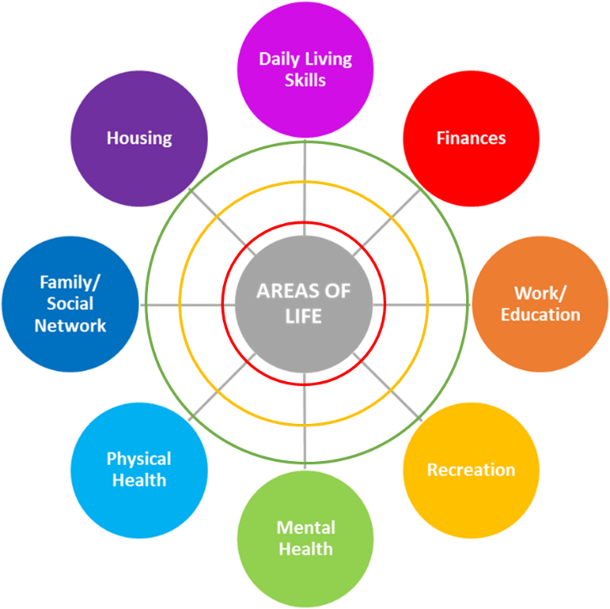
Asset based approach – This helps us to think about where you are and where you would like to be in all areas of your life. We will complete this together at the start of your time in the service and again at regular intervals to measure the progress you are making during your time in the service.

Risk assessments and crisis/safety plans - We complete risk assessments to identify areas where you or others might be at risk of harm, and we use this to agree actions which help reduce this risk. If you experience increased distress, we may write a crisis or safety plan to help both you and the staff members supporting you.
Psychologically Informed Environment (PIE) – We operate as a psychologically informed environment, meaning we believe peoples’ behaviours are often dictated by a difficult past. We will help you to address these issues so they have less of an impact on your life as you work towards recovery and independence.

The Housing Support Worker role
You will be allocated a Housing Support Worker. They will work closely with you to identify support needs and develop support plans, but all members of staff are available to you for support.

What we can do
We can support you with:
- applying for social housing or registering with letting agencies;
- applying for benefits such as Universal Credit, Personal Independence Payments or Housing Benefit (we may refer you for more intensive support from a specialist support service);
- notifying the Department of Work and Pensions (DWP) / Local Authority of a change in circumstances, such as moving house;
- applying for funding for furniture, carpets and housing related items;
- setting up household bills – i.e gas, electricity, water, council tax;
- setting up payment plans to clear housing related arrears – i.e rent arrears, water bill arrears;
- managing a budget;
- dealing with issues around benefits (we may refer you to a specialist support service);
- dealing with correspondence relating to your housing needs.
We can also support you in accessing other services – we can make a referral and support you through the initial assessment phase. These services may include:
- legal services for eviction/possession court proceedings;
- mental health services (NHS or voluntary organisations);
- addiction recovery services;
- social support / volunteering groups;
- employment or education services;
- foodbanks;
- domestic violence support;
- Social Services;
- Citizens’ Advice Bureau or advocacy services for support with other non-housing related issues

What we cannot do
- Accompany you to routine mental health appointments or medical appointments;
- Accompany you to regular Jobcentre appointments - i.e signing on;
- Search and bid for housing (social or private);
- Deal with non-housing related debts or issues;
- Provide financial assistance;
- Provide mental health therapies or interventions.

Support Agreement
A Support Agreement is a contract between you and your Support Worker, which sets out the terms and conditions of your support. You will be issued a Support Agreement on the day you start working with your Support Worker, which you should read carefully.
We will respond to your calls, texts or emails within 3 working days. If your enquiry is urgent, please call the office on 01904 526240 or call 01904 630500 for out-of-hours support.

Confidentiality
Community Links need to hold some information about you in order to support you. This is done in line with the General Data Protection Regulations (GDPR), which sets guidelines for the collection and processing of personal information. We only collect information we need, which will then be stored, distributed and where appropriate, destroyed securely. We will only share your information on a need to know basis when you have given consent for this, or if we have concerns for the safety of you or others.

Access to your information
You can request to access the information we hold about you. This will be facilitated at the earliest opportunity and within 3 working days of the request. This enables arrangements to be made for privacy, the removal of third party notes and worker input.
You can ask your Support Worker for support in accessing your information.
Your carers are not able to request information held about you without your consent.

Diversity
We are proud to be part of a diverse community and are committed to eliminating discrimination and promoting equality.
We aim to treat everyone with dignity and respect, regardless of age, disability, gender identity, race, religion or belief, sexual orientation, marriage or civil partnership status, pregnancy or maternity status (protected characteristics).
ENDING RACISM IS EVERYONE’S BUSINESS
Our commitment is to not do what traditionally has happened in society previously with the issue of racism, in that it is focussed on for a short period of time. We will be holding ourselves accountable to ensure there are sustainable changes made wherever necessary to end racism.

Although we understand everybody is entitled to their own views, while within the service you will be challenged if you behave in a way which discriminates against others.

Boundaries
We want you to feel comfortable and confident when speaking to staff members during your time with the service. We aim to build working relationship with you and provide a friendly service. This relationship should be viewed professionally and both you and your Support Worker are responsible for keeping boundaries in order to maintain a safe relationship.
Staff will not share their address, personal phone number, social media details, meet with you outside of their working hours or form an intimate or personal relationship with you.
We understand that on occasion, some people want to give their worker a gift, however the value should amount to no more than £10 and should never negatively affect your ability to manage your finances. This to protect both you and staff from risk of exploitation or allegation.

Your Rights
You have the right to:
- A staff team who do not tolerate and always challenge any form of discrimination, anti-social behaviour and bullying;
- Confidentiality;
- Be treated with compassion, dignity, sensitivity and respect;
- Receive visitors and friends;
- Be fully involved in your support;
- Express your preferences and opinions;
- Make a complaint, compliment or suggestion about any part of our service.

What We Expect From You
- To be actively involved in your support and engage with staff;
- Not to engage in anti-social or discriminating behaviour against staff and other people who live with you (for those in shared accommodation only)
If you do not follow these expectations, you may put your tenancy at risk. We will work with you to help solve any issues that may put your tenancy at risk, but if you do not engage in this process or take the actions agreed between you and your Support Worker, we will not be able to support you effectively and may lead to your discharge from the service.

Safeguarding
Safeguarding means protecting vulnerable adults or children from abuse or neglect. The staff team is trained to identify potential concerns, and will always aim to act before harm occurs. If abuse is suspected we will use the least intrusive response available to respond to the risk presented.
We all have our part to play in preventing, detecting and reporting neglect and abuse so if you suspect it, report it. Ask a staff member for a safeguarding leaflet if needed.

Smoking
Please do not smoke in the presence of your Support Worker. Staff reserve the right to terminate your support session if you continue to smoke in their presence.

Drug Use
Please do not take drugs in the presence of your Support Worker. If you are deemed to be under the influence of drugs, your Support Worker will decide whether it is appropriate to continue your support session. They may choose to rearrange for another time. If you regularly miss appointments or are too intoxicated to engage with support sessions, you may be discharged from the service.

Alcohol use
Please do not drink alcohol in the presence of your Support Worker. If you are deemed to be under the influence of alcohol, your Support Worker will decide whether it is appropriate to continue your support session. They may rearrange for another time. If you regularly miss appointments or are too intoxicated to engage with support sessions, you may be discharged from the service.

Client Involvement and Co-production
We encourage you to get involved and have a say in the service and organisation. You can do this in the following ways:
- Follow us on Twitter and Facebook;
- Complete feedback forms online or through your Support Worker;
- Get involved in planning of Community Links events;
- Attend training in recruitment and interviewing new staff (a paid opportunity);
- Review our policies and support the Directors to audit services;
- Visit other Community Links services with a Manager to complete a quality audit (a paid opportunity);
- Attend working groups, such as our health and safety group or diversity group;
- Become a client representative on our Management Committee or sub-committees.
Speak with staff if you are interested in any of these opportunities or have any other ideas of ways you could get involved.

Advocacy
It can be frustrating when people are not listening to you or taking you seriously. Unfortunately, having a mental health problem can sometimes mean it is even harder to have your opinions and ideas taken seriously by others.
Advocacy means getting support from another person to help you express your views and wishes, and help you stand up for your rights.
We are committed to ensuring that all of our clients have access to advocacy services. Please see our Advocacy Services in York leaflet which provides more information about local services which are able to provide advocacy services.

Compliments, complaints and suggestions
We are committed to providing a high-quality service. In order to do this, we need you to tell us when we get things wrong, when we get things right and where we can improve.
If you have a complaint, we want to help you resolve as quickly as possible.
To do this, you can -
- Ask a staff member for a paper copy of our compliments and complaints leaflet.
OR
- Complete the form online on our website at: https://www.commlinks.co.uk/contact/have-your-say/
OR
- Scan this QR code which will take you straight to our online form –

